**Assignment**

Prateek Khandelwal

1. Which software development technique is good for the systems that have third party API calls, cron jobs, data exports/imports, etc.,

Ans.) For systems with third-party API calls, cron jobs, data exports/imports, etc., Test Driven Development (TDD) might be a better solution.

1. Where does Test Automation fit in the Software Life Cycle? Explain with a diagram.

Ans.)Test Automation fits within the development and testing phases. In the Waterfall model shown, it appears between the Development and Testing phases. In the Agile model, it is shown as part of the iterative cycle, closely linked between the 'Develop' and 'Test' stages within each loop.  
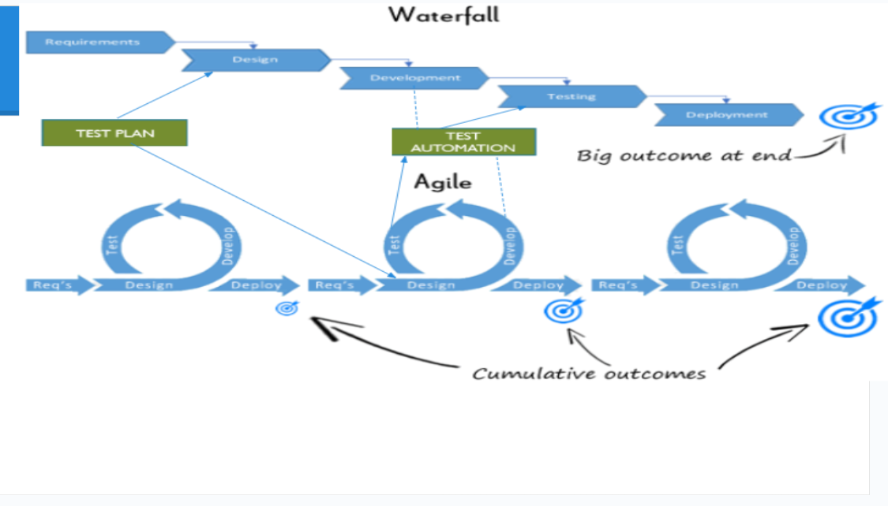

1. Can we skip the manual testing and why?

Ans.)No, we cannot completely skip manual testing. Slide 65 explicitly states "YES!!" manual testing is still needed. While repetitive manual tests (like regression) should be automated, manual testing, specifically exploratory testing, is essential because humans are better at finding new, unexpected defects.

1. Give the names of the selector(locators) ?

Ans.) XPath and CSS selectors as necessary skills for web testing, which function as selectors/locators.

1. What is the modular framework?

Ans.)The Modular framework involves creating independent, reusable scripts or functions (often in a test library) that represent specific modules or functionalities. A main 'driver script' calls these modules to execute test cases. This approach promotes reusability (objects defined once) and breaks down tests into smaller, manageable parts

1. Explain the Open source tool.

Ans.)According to Slide 60, Open Source tools are characterized by having their source code available. They offer a large variety, are generally easy to integrate, are free of cost, and allow for customization. Because the code is open, they "can never really die" (i.e., less risk of discontinuation).

1. What is a Hybrid framework?

Ans.)A Hybrid framework, combines two or more different framework approaches (e.g., Modular and Data-Driven, or Keyword-Driven with custom scripts) to leverage their respective strengths and minimize weaknesses.

1. Write a name of record and replay tool.

Ans.) Selenium IDE as an example of a record and playback (replay) tool.

1. What is the difference between BDD and Cucumber?

Ans.)The Difference between

* BDD is in a more readable format by every stake holder since it is in English, unlike TDD test cases written in programming languages such as Ruby, Java etc.
* BDD explains the behavior of an application for the end user while TDD focuses on how functionality is implemented. Changes on functionality can be accommodated with less impact in BDD as opposed to TDD.
* BDD enables all the stakeholders to be on the same page with requirements which makes acceptance easy, as opposed to TDD.
* The behavior of the application is the central idea in BDD; it focuses on the customer and pushes developers and testers to walk in the customer’s shoes. If actions do not affect the end-user, BDD might not represent such a scenario very well, in which case TDD better serves the purpose.
* Like many other software development practices, it might not be feasible to identify what works universally for all projects. For systems that are driven by actions of the end user such as an ecommerce website or a HR system, BDD acts as a good medium to capture all the user actions. For systems that have third party API calls, cron jobs, data exports/imports, etc., TDD might be a better solution.

1. Can we replace the Manual Regression testing effort from Test automation and how?

Ans.)Yes, the presentation suggests that manual regression testing effort can largely be replaced by Test Automation . This is done by creating automated test scripts that form a regression suiteto repeatedly check existing functionality quickly and ensure new changes haven't introduced bugs. Machines are noted as being "great for running regression tests"

1. How many ‘A’s test script has? Explain them.

Ans.)A test script has three 'A's:

ARRANGEMENT / Object Identification: Setting up test preconditions and identifying UI elements.

ACTION: Performing the interactions with the application.

ASSERTION: Verifying the outcome against expectations.